3. Description of autoISF / guidance by developers
V.1.5
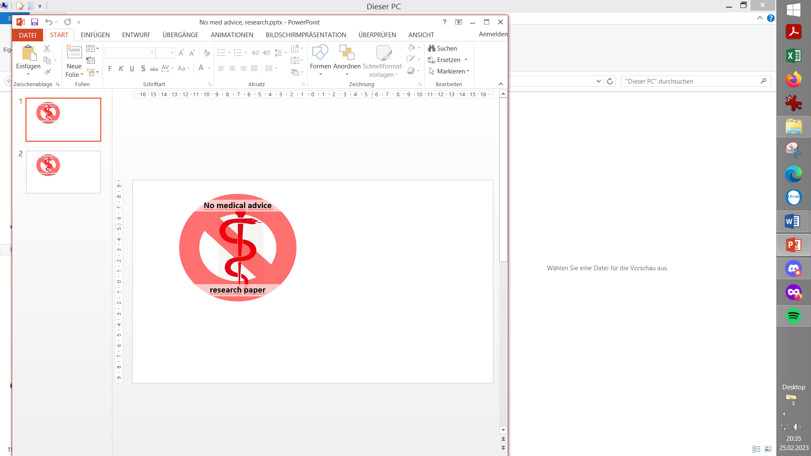
Please note that with autoISF you are in an early-dev. environment, where the user interface is not optimized for safety of users who stray away from intended ways to use. Good safety features exist, but these are only as good as the development-oriented user understands and implements them. This is not a medical product, refer to disclaimer in section 0

Related case studies:

Links to more case studies or detailed docu on special topics: See section 3.10
3.1 Overview
3.2 ISF modulation flowcharts
3.3 Exercise mode and dynamic iobTH
3.4 Automation options with autoISF parameters
3.5 Activity monitor
3.6 Using one-minute CGM (Libre 3)
3.7 Smooth transitioning when calibrating CGM
3.8 AutoISF parameters overview table
3.9 Emulator for logfile analysis and tuning
3.10 Links to related case studies/detailed doc.s

3.1 Overview

autoISF can be used to refine the workings of your Hybrid Closed Loop.
If you use autoISF for Hybrid Closed Loop, you exclusively can do so by studying the documents linked in this section 3, all available from Github/ga-zelle (repo autoISF and repo APS-what-if).

Note that the apk to build your autoISF variant of AAPS (and the installation instructions for your looping app) is elsewhere: https://github.com/T-o-b-i-a-s/AndroidAPS/;
For Trio see https://github.com/mountrcg/Trio, and iAPS see: https://github.com/mountrcg/iAPS

autoISF allows also to build a top performing Full Closed Loop.

FCL is the sole topic in all other sections of this FCL e-book. https://github.com/bernie4375/FCL-potential-autoISF-research
-

The general workings of autoISF are best characterized with the chart that is included in section 4.1. . It sketches which of the autoISF parameters have a key role of managing your bg curve, in its characteristic different post-meal stages.

A comprehensive description of autoISF is the main developer’s

autoISF Quick Guide here:
https://github.com/ga-zelle/autoISF

See screenshot below for current content. Always watch out to use the most up-to-date branch
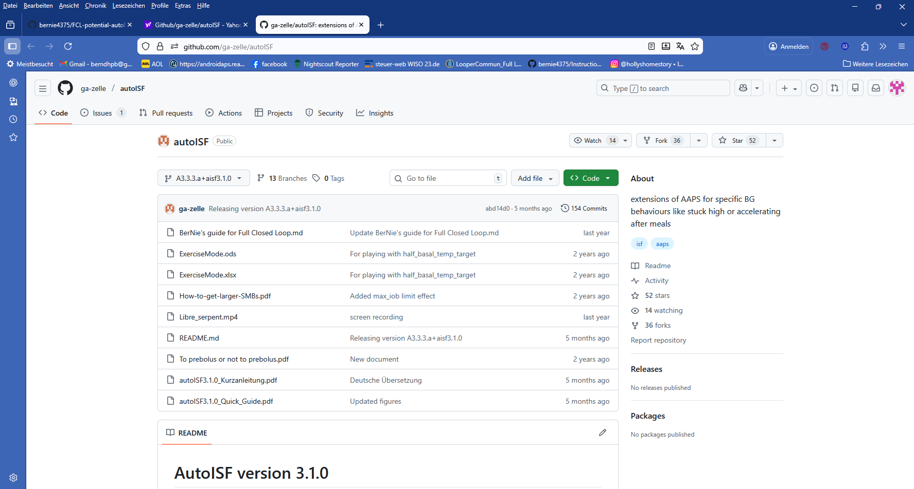
Note: The developer provides some materials also in German language in (t)his Github repo.

3.2 ISF adaptation flowcharts

autoISF calculates every 5 minutes (and more often if you use Libre3) an ISF (called sens) to use in place of your profile_ISF (profile.sens, which remains an important anchor point).

autoISF 3.1 ff users on Android can see on the 1st page of their AUTOI ISF tab, how these calculations (and how their individual settings re. profile, safety limits, but also set TT etc.) determine sens and SMB size.

Set of flowcharts describing calculation of sens (the concluded effective ISF to use, as in AUTO ISF tab (in former versions: SMB tab:)
- page 3 – 7 of the Quick Guide: https://github.com/ga-zelle/autoISF
:

3.3 Exercise mode and dynamic iobTH

autoISF is geared towards aggressive treatment. However, in an exercise context, it is desirable to have built-in features that allow manage situations with much less typical insulin need.

autoISF has several special features to address this, which all are described here:

Exercise mode:
- on page 8 of the Quick Guide: https://github.com/ga-zelle/autoISF

Dynamic iobTH:
- is explained under the headline “internal automation for iobTH” on page ?? of the Quick Guide: https://github.com/ga-zelle/autoISF
- Calculators to determine how half-basal exercise target, set TT influence sens and iobTH, (in .xls or odt format), here: ExerciseMode.xlsx and Exercvise Mode.ods in: https://github.com/ga-zelle/autoISF
Consult Section 6 of this FCL e-book for more guidance to find appropriate exercise-related settings for your favorite types of exercise

SMB delivery ratio:
- on page 11 of the Quick Guide: https://github.com/ga-zelle/autoISF

Even/odd target (for SMB on/off)
- see page 12 of the Quick Guide: https://github.com/ga-zelle/autoISF

Loop power level characterization in the SMB tab
- is explained see page 16 of the Quick Guide: https://github.com/ga-zelle/autoISF

The ai % indicator underneath the Autosens % on the AAPS screen
- is explained also onpage 16 of the Quick Guide: https://github.com/ga-zelle/autoISF

3.4 Automation options with autoISF parameters

autoISF provides AAPS users an expanded set of Conditions and Actions to choose from, when setting up an Automation.

autoISF parameters available in Automations (as Condition, and/or Action) are described:
- on page 13 of the Quick Guide: https://github.com/ga-zelle/autoISF
Caution: In FCL with AutoISF, please do not rush into setting up lots of Automations to “fine tune” (this is discussed in detail in section 4.6-4.7, and section 5.). Rather, first try to do a good job following (in FCL) the sequence as laid out in the FCL e-book.

Automation of States (new from autoISF V.3.1)

See Quick Guide p.14-15

3.5 Activity Monitor

autoISF also comes with an Activity Monitor. You can calibrate it to your personal sensitivity swings as they may relate to stepcount, or to periods of total in-activity.
Activity monitor description:
- see page 8 of the Quick Guide: https://github.com/ga-zelle/autoISF

3.6 Using 1-minute CGM (Libre3)

1 minute Libre3 data use in autoISF:
- go to page 17-20 of the Quick Guide: https://github.com/ga-zelle/autoISF
Especially if you go for FCL: The issue over-arching your hope for avg maybe 2 minutes earlier clues from the CGM must be: Solid non-jittery performance (see section 1.4).

3.7 Smooth transition when calibrating

- go to page 21 of the Quick Guide: https://github.com/ga-zelle/autoISF

3.8 Additional parameters in autoISF (18), and recommended start settings

The table in Attachment 1 of the Quick Guide (~p. 22) gives an overview of additional settings if you operate autoISF to its full potential.

The default, and recommended start of tuning suggestions in this table are made for Hybrid Closed Loopers.
For FCL, please consult this FCL e-book

Table showing all autoISF parameters w/ default settings see: all autoISF parameters see: …
- on page 22 of the Quick Guide: https://github.com/ga-zelle/autoISF

autoISF settings screen in AAPS/Preferences, see:
- last page of the Quick guide = page 22 : https://github.com/ga-zelle/autoISF
- specifically, relating to Libre and Juggluco: page 23

3.9 Emulator for AAPS logfile analysis
The links given in section 3.8 are numbered for easier referencing in other text.

It can be impractical to real-time inspect the AUTO ISF tab (or take screenshots for later inspection).

To determine which of your settings should be changed for better performance, the autoISF developer provides:
- Info in extra graphs below the AAPS main screen
- An extra tool, the Emulator. It is described in another repo:

1).Emulator instructions see:
https://github.com/ga-zelle/APS-what-if (watch for latest version, branch)
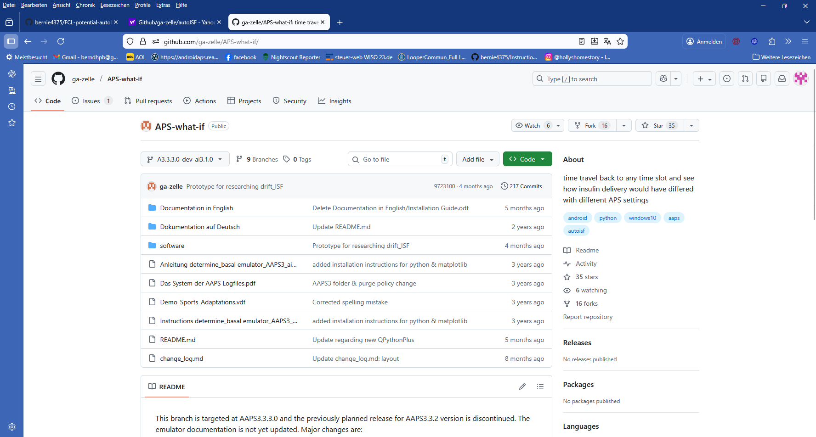
Note: “what-if” is another branch than the “autoISF” that we have looked into so far!
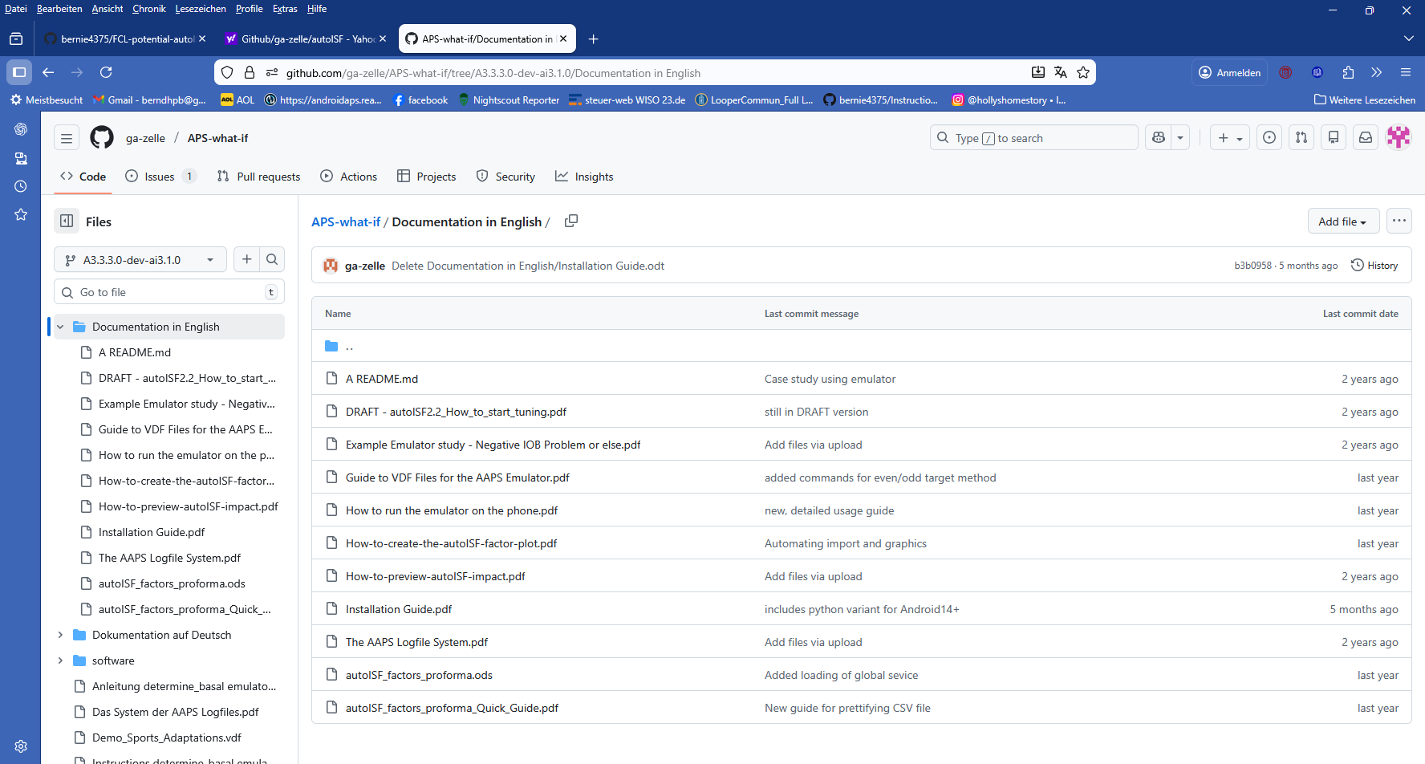

2).Emulator installation guide see:
- https://github.com/ga-zelle/APS-what-if /Documentation in English
FCL e-book sections 10 (PC) and 11 (phone) offer additional installation guidance.

3) How to run the emulator on the phone see section 11 of FCL e-book, and files under Documentation in English in:
https://github.com/ga-zelle/APS-what-if

4).How to start tuning guide for Hybrid Closed Loop using autoISF, files under Documentation in English in:
https://github.com/ga-zelle/APS-what-if
Caution: If you go Full Closed Loop with autoISF, please primarily consult this FCL e-book, sections 2 and 4!

Note that tuning your settings for Full Closed Loop is a very difficult project in which you should follow the sequence of sections 1 -6 of this e-book.
FCL e-book sections 10 (PC) and 11 (phone), plus associated case studies, offer additional guidance for interpretation and tuning, with focus on application in Full Closed Loop.

Especially in your “section 4 phase”, the Emulator is a great tool to use (refer to sections 10 and 11),

Note: This “emulator” tool does not require building an apk.
Go to “software” and download the needed (mostly python) files. Then follow installation guide(s).
See also FCL e-book section 10.

5).Software download for PC and Android phone here:
- https://github.com/ga-zelle/APS-what-if

For your what-if investigations, there are examples of .vdf files offered to download (for use as-is, or for easy further customization):
- Demo_Sports_Adaptations.vdf in: https://github.com/ga-zelle/APS-what-if
Regarding customization, see:
- How to write vdf files
- and see also FCL e-book section 10.3.1.
Regarding how to transfer onto your phone, see:
- How to load vdf files into your phone
- and see also FCL e-book see also section 11.4.1

6). Investigating concurrently more than one “what-if” on the phone
You can check the data of your currently running loop (decisions of the last 15*5 minutes) also for two or three “what-if I changed such and such parameter setting” scenarios, by just switching between the related vdf files.
Details see How to run the emulator on the phone
- there p.5, under above sub-headline “.Stop the emulator, or switch…”
in: Documentation in English in: https://github.com/ga-zelle/APS-what-if

The emulator can also be used for AAPS SMB+UAM without (or with only a few) autoISF features utilized.
It is not designed for use with dynamicISF, though.

3.10 Links to related case studies or other detailed documents
The links given in section 3.9 are numbered for easier referencing in other text.

1).reserved for =case study 3.1:
(link)#

2).To pre-bolus or not to pre-bolus = case study 3.2:
https://github.com/ga-zelle/autoISF/

3).Example emulator study – Neg. iob… analyzes a negIOB situation with help of the emulator (= case study 3.3) see under Documentation in English in: https://github.com/ga-zelle/APS-what-if

4).reserved for =case study 3.4:
(link)#

5).reserved for =case study 3.5:
(link)#

6).How to get larger SMBs see under Documentation in English in: https://github.com/ga-zelle/APS-what-if

7).How to pre-view autoISF impact
see under Documentation in English in: https://github.com/ga-zelle/APS-what-if

See also extra graph options below the AAPS main screen-

8).How to create the autoISF factors plot
see under Documentation in English in: https://github.com/ga-zelle/APS-what-if

From autoISF 3.2, a factor plot will be available also as extra graph underneath the AAPS main graph (when scrolling down the AAPS main screen on the phone)

9).Guide to vdf files for emulator - see also above (=section 3.8, 6)-8) and:
- file named “Guide to vdf …” in: https://github.com/ga-zelle/APS-what-if
- and FCL e-book, section 10.3.1

